Why Do People Buy What They Buy?
Testing What Makes a Product Look More Appealing
Avante Science • Elementary Science Fair • Behavioral Science & Consumer Psychology

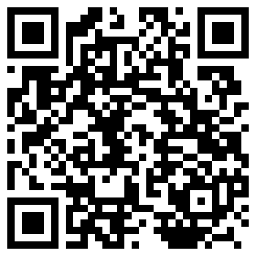 | 📺 Intro Video  Scan the QR code with a phone or tablet, or visit:  https://www.youtube.com/watch?v=QNkHl2AZmTg

🔎 Background — What's Going On?
People shop on sites like Amazon every day. With so many choices, it can be hard to pick! Websites use features like star ratings, number of reviews, discounts, and “best seller” badges to help shoppers choose. Some shoppers care most about price; others trust a product with lots of reviews or a high rating.
In this psychology experiment, you'll test which feature influences people the most when deciding what to buy — instead of testing chemicals or plants, you're testing how people think and make decisions!

❓ Scientific Question
What influences someone's decision to buy a product online?

💡 Hypothesis
You will test ratings, number of reviews, and other features. Predict which feature helps sell products best.
I predict the feature that helps sell the most will be ________________________. I think it will matter more than ________________________. The reason is ________________________.

🧰 Materials
• The 4 product comparison pages (on page 2 of this handout)
• The data table below
• At least 10 willing test subjects (friends or family)
⚠️ Safety: Always ask permission before asking someone to take part in your experiment. Ask an adult before you begin, and clean up when you finish.

🔬 Let's Experiment! — Step by Step
1. Look at the 4 product pages on page 2. Each shows the same product with one detail changed — like the star rating or number of reviews.
2. Find a test subject (a friend or family member).
3. Show them 2 of the 4 pages, following the pairs listed in the data table.
4. Ask which product they would rather buy and record their answer.
5. Repeat with 9 more people, for 10 people in total.

📊 Data Table — Record Your Results
First Option | Second Option | P1 | P2 | P3 | P4 | P5 | P6 | P7 | P8 | P9 | P10
1 | 2
1 | 3
1 | 4
2 | 3
2 | 4
3 | 4

✏️ Conclusion — What Did You Find?
Use this fill-in template to write your conclusion. Answer in complete sentences.
This experiment tested which product features affect what people choose to buy.
The results show that ________________________ was the most important feature. ________________________ was not.
My prediction was ________________________. As you can see from the data, this prediction was ____________ (correct / incorrect).

🌟 Bonus Challenge (Optional)
Try testing adults and kids separately. Do they pay attention to the same features?

📎 Product Comparison Pages
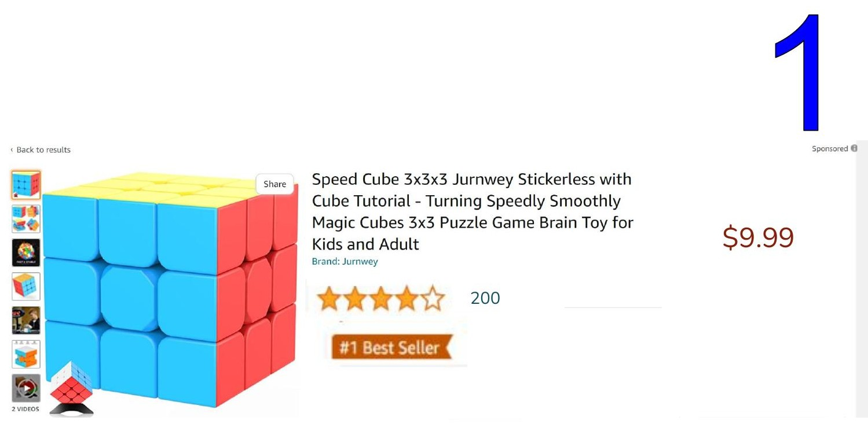 | 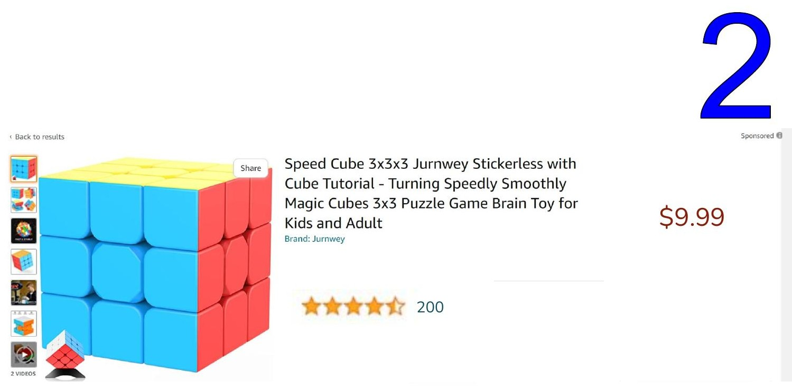
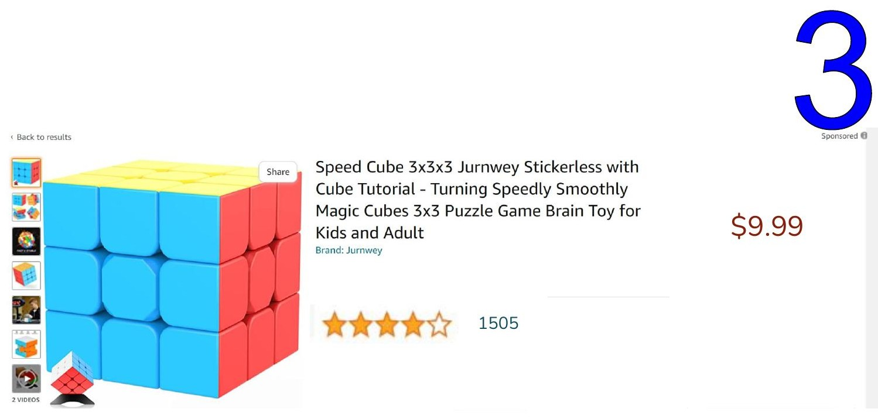 | 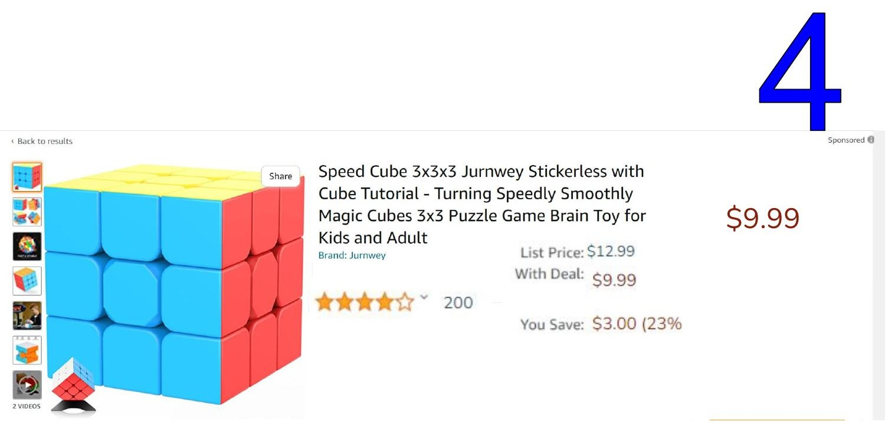

Avante Science | avantescience.org | Empowering young minds through equitable, hands-on science education

